Bioinformatics for Biologists - Spring 2021

Study guide for Applied test 1.

- What is this protein? What species is it from?

MAQNDSQEFAELWEKNLIIQPPGGGSCWDIINDEEYLPGSFDPNFFENVLEEQPQPSTLP PTSTVPETSDYPGDHGFRLRFPQSGTAKSVTCTYSPDLNKLFCQLAKTCPVQMVVDVAPP QGSVVRATAIYKKSEHVAEVVRRCPHHERTPDGDNLAPAGHLIRVEGNQRANYREDNITL RHSVFVPYEAPQLGAEWTTVLLNYMCNSSCMGGMNRRPILTIITLETQEGQLLGRRSFEV RVCACPGRDRKTEESNFKKDQETKTMAKTTTGTKRSLVKESSSATLRPEGSKKAKGSSSD EEIFTLQVRGRERYEILKKLNDSLELSDVVPASDAEKYRQKFMTKNKKENRESSEPKQGK KLMVKDEGRSDSD

- What species is the protein with UNIPROT accession P79734 from?

- Build a common (species) tree for the following species (tax ids: 7757, 8030, 81824, 256737).
  - Which tax id is the outgroup?
  - What are the species names for these tax ids?
  - For these species, what is the species name of the outgroup?

- For a given sequence, e.g. >NP_001079353.1 bone morphogenetic protein 2-A precursor [Xenopus laevis]
- What is the length of the protein?
- What is the GeneID?
- What species is it from?
- Are there any isoforms for the protein above? (Yes/No)
- Are there any paralogs of this protein in the same species? (Yes/No)
- Is NP_001095263 an isoform or a paralog of the protein above?
- Is XP_018119713 an isoform or a paralog of the protein above?
- Are there any homologs for this protein in Gorilla gorilla?
- If H=yes, what is the query cover, E-value, and Ident (sequence identity) for the protein shown above and the best hit (for Gorilla gorilla, ranked by e-value)?
- Are there any homologs for this full-length protein in species Arabidopsis thaliana in the
refseq protein database?

- Retrieve the following sequences from NCBI and align the sequences with Muscle default in Jalview or using Muscle at EBI (https://www.ebi.ac.uk/Tools/msa/muscle/): XP_009561549, XP_009819800, XP_014041481, XP_014350442 (see fig below for how to extract the sequences quickly)
What is the length of the multiple sequence alignment?

A. 494 B. 504 C. 514 D. 532
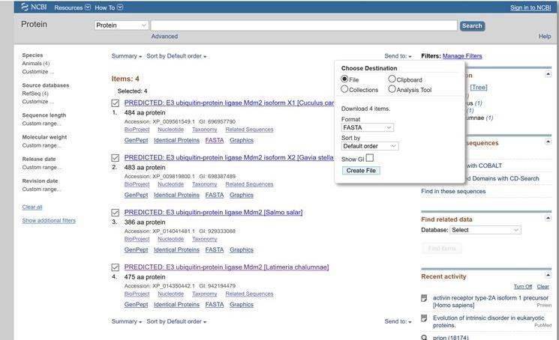

- Use NCBI BLAST to identify a template for homology modeling for a certain sequence (example below). What is the pdb id for the best template (sorted by e-value)? What is the e-value, query cover, and percent identity for the best (sorted by e-value) target-template alignment?

>XP_009561549.1 PREDICTED: E3 ubiquitin-protein ligase Mdm2 isoform X1 [Cuculus canorus] MCNTEMSSLTDASAVTASEREALVRPKPLLLRLLKLAGAEKDTFTMKEVIFYLGQYIMSKQLYDEKQQHI VHCANDLLGDLFGVTSFSVKEHRRLYSMISRNLIAVSQQDSRHADTPEDDARFQLEEENSLKESIQELEE KQTSSNVTSRPTTSSRRRPHSESEENSSDDLHSDRRKRHKSDSISLTFDESLSWCVVSGLCRERSNSSDS TDSLSIPDLDASSLSENSDWFDHSSVSDQFSVEFEVESIYSEDYNHNEEGQELTDEDDEVYQLTIYQDED SDADSFDEDPEISLADYWKCPECSEMNPPLPRHCHRCWALREDWLPDEKSDKSVKSKLESSLPLESEEGF DVPDCKKVKMIEDKEPALEENEDKAAQISESQESEDYSQPSTSSSMFCSSQEDYKEPEKRETQDKEESIE SSLPVTSIEPCVICQSRPKNGCIVHGKTGHLMSCFTCARKLKKRNKPCPVCRQPIQMIVLTYFS

- For a specified PDB id, e.g. 1phz,
- What is the resolution?
- What ligands are present in the structure?

- Which of the following PDB structures have the highest resolution?
A) 1XFU B) 2YGG C) 3EWT D) 4HEX

- How many homologs (with an e-value below 1e-30 [nr database]) of a given protein can you find in a given species (perhaps in a given database – although the database may also not be given)? E.g. how many homologs of protein AAA39883.1 can you find in Plasmodium falciparum in the nr database?

9.5 For a given sequence: MALWMRLLPLLALLALWGPDPAAAFVNQHLCGSHLVEALYLVCGERGFFYTPKTRREAEDLQVGQVELGGGPGAGS LQPLALEGSLQKRGIVEQCCTSICSLYQLENYCN
- what is the protein?
- what is the predominant secondary structure in this sequence based on PSIPRED prediction?
- While your PSIPRED prediction is running: Are there any experimental protein structures of this protein (in the PDB)? Hint: BLAST
- Based on your PSIPRED results: Which residue has the lowest confidence (e.g. P9 or F25)?

- Use PyMOL to determine if a given protein is a monomer, dimer, trimer, etc. or what the secondary structure is of a given residue. Combine with PSIPRED to determine if it is a true positive, false positive, true negative or false negative.

To be covered for Day 10-11

- PFAM
- What are the PFAM domains of a certain protein
- How many domain architectures are given domain found in?
- Which species have a certain domain?
- How many sequences are in the full alignment? How many sequences are in the seed alignment?
- What are characteristics of the three most common amino acid found at a specific site in the HMM Logo for a given PFAM domain? For instance, site 203 in PFAM domain PF02171
- What is the most common amino acids at site 217 in PFAM domain PF02171?

- KEGG
Based on a given Pathway, what are specific interactions? For instance, for KEGG PATHWAY: Pathways in cancer - Homo sapiens (human) (genome.jp) which proteins are phosphorylated by ERK? How does MEK activate ERK? How does PIP3 contribute to the regulation of GSK-3β?
  - Remember the Help button

